

**MINISTRY OF EDUCATION AND TRAINING**

**FPT UNIVERSITY**

Capstone Project Document

**Cosmetic Online Shopping**

|  |  |
| --- | --- |
| **Group 2** | |
| **Group members** | Võ Huỳnh Đức Minh – SE130160 Nguyễn Công Bảo – SE130160 |
| **Supervisor** | Hồ Hoàn Kiếm |
| **Ext. Supervisor** | N/A |
| **Capstone Project Code** | COSA |

- Ho Chi Minh City, 5 April 2020 -

This page is intentionally left blank

Table of Contents

Contents

Table of Contents 3

A. Introduction 4

1. Project Information 4

2. Introduction 5

3. Current Situation 6

4. Problem Definition 6

5. Proposed Solution 7

6. Functional Requirements 7

7. Roles and Responsibility 8

B. Software Project Management Plan 8

1. Problem Definition 8

2. Project Organization 9

C. Software Requirement Specification 11

1. User Requirement Specification 11

2. System Requirement Specification 11

3. Software System Attribute 36

4. ER Diagram 36

D. Software Design Description 38

1. Design Overview 38

2. System Architecture Design 38

3. Component Diagram 39

4. Detailed Description 41

5. Sequence Diagram 46

1. Introduction
2. Project Information

* Project name: **Cosmetic Online Shopping**
* Project code: **COSA**
* Product Type: **Website Application**
* Start Date: **March 12, 2020**
* End Date: **April 5,2020**

1. Introduction

In this document, we introduce a solution for online shopping stores. The current model of offline shopping is inconvenient for user to shopping with a heaps of task to do before bring their product from shop center to home.

This project Online Shopping System is very helpful for where the customer can directly buy the products or items from home through internet connection on mobile or system. This project reduces lot of work load for customer as well as owner. The transaction of money is completed in real time system. By this online shopping items is directly delivered to buyer home. Online Shopping System can help to manage goods, products and services online by choosing the listed products from online shopping store websites.

The main of this project helps in sell products or goods online through internet connection. Buying of products online, customer can choose different products based on categories, online payments, delivery services and covering the disadvantages of the existing system and making the buying easier and helping the vendors to reach wider market. This system helps to choose products faster and easier at one place. This system can also help for saves time of travelling to the seller’s place. Products bought online will be delivered to the footsteps of the buyer free of cost. The objective of this project is to develop a general purpose e-commerce store where any product like books, computers, mobile phones, electronic items, baby care items can be bought from home through the Internet.

An online store is a virtual store on the Internet where users can browse the catalog and select products of interest. The selected items may be collected in a shopping cart. At checkout time, the items in the shopping cart will be presented as an order. At that time, more information can needed to complete the transaction. The customer asked to fill or select a billing address, a shipping address, a shipping option, and payment information like credit card or debit card number. This project is a very useful for e- mail notification is sent to the customer as soon as the order is placed.

1. Current Situation

Nowadays, technology is gradually developing, people’s need is increasing day by day. Besides, commerce issues to satisfy people to become more and more important. Whenever they want to buy something, they will spend a lot of time and money on going to the shop they like. Not only that,but also the store has difficulty attracting customers inconvenient.

In the scenario, in order to prepare for shopping-times, Our company decided to establish a new system called e-Shopping – sales service online. Such a system not only save time and cost for customers but also help the company more convenient in releasing product quickly to everyone and the company brand will be more popular. In the future, there is a possibility that customers will receive many sales promotion and gifts from the company without spending time on going anywhere.

Otherwise, the online shopping model helps everybody safe from the virus because of going out-side and prevent hand-to-hand buying product, with the old shopping model.

1. Problem Definition

Below are disadvantages of current situation:

* Inconvenient to a user from moving: user needs to going outside and go to shop by vehicle. This is a big problem with the amout of user who can’t control the vehicle.
* Distance problem: Now consider user who lives far from shopping center can enjoy their shopping time easier.
* No mechanism and paperless: Users don’t need to bring a ton of bills after buying plenty of products and keep tracking them after that. Everything is memorizing automation with technology
* Wasting time: user need to spend a lot of time to find their product. And keep waiting when making payment. With technology solutions, user’s request is more quickly and save time

1. Proposed Solution

* Web application:  
  **Display shop’s items:** user can watch some recommendation product display on shopping web site and interactive with them by click on product to view product detail.  
  **Search product:** user can find the product by fill the search text box on top and click on search to searching product.  
  **Shopping cart:** after view product, user can add them to cart collection and update quantity of product. The total price of shopping cart will display on bottom corner of page . Finally, user can submit order with their choice about payment and delivery.  
  **Manage user account:** Admin can modify or set role of user account and manage their information.  
  **Mange product store:** Admin can create new product, modify exist product or delete them on store.  
  **Check register validation:** all the field of register page will be validate to conform with the system require.

1. Functional Requirements

* User Component  
  - Register Account  
  - Login  
  - Logout  
  - View product list  
  - View product details  
  - Shopping Cart  
  - View history
* Admin Component  
  - Set role account  
  - Manage user accounts  
  - Manage products
* System Component  
  - Manage login states
* Payment Component  
  - Process payments
* Delivery Component  
  - Process deliverys

1. Roles and Responsibility

|  |  |  |  |  |
| --- | --- | --- | --- | --- |
| No | Full Name | Role | Position | Contact |
| 1 | Hồ Hoàn Kiếm | Project Manager | Supervisor | khanhkt@fpt.edu.vn |
| 2 | Võ Huỳnh Đức Minh | Developer | Leader | trungdqse60994@fpt.edu.vn |
| 3 | Nguyễn Công Bảo | Developer | Member | Baoncse130160@fpt.edu.vn |

1. Software Project Management Plan
2. Problem Definition
3. Name of this Capstone Project  
   - Official name: Cosmetic Online Shopping  
   - Vietnamese name: cửa hàng mỹ phẩm trực tuyến  
   - Abbreviation: COSA
4. Problem Abstract  
   Nowadays, the trend of offline buying has become outdated and no longer competitive with the online shopping model. There are many reasons that have changed customer behavior such as inconvenience in moving, wasting time when choosing products, or complicated forms of payment, especially in cosmetic products.

The creation of an online shopping website is necessary for the needs of a large market like Vietnam. Therefore, it can completely solve the essential issues and ensure the safety of users in the context of a serious outbreak.

1. Project Organization
2. Software Process Model

This project is developed under waterfall model. We apply customized waterfall model to capable with current situation in our team. We choose this model because the following reasons:

* This project is 2 months long due to the FPT University Capstone Project timeline, which can be consider a short project.
* Based on researches and clarify online shopping trend in current system in cosmetic companies, the requirements of this project are stable, clear, fixed and well understood by all team members.

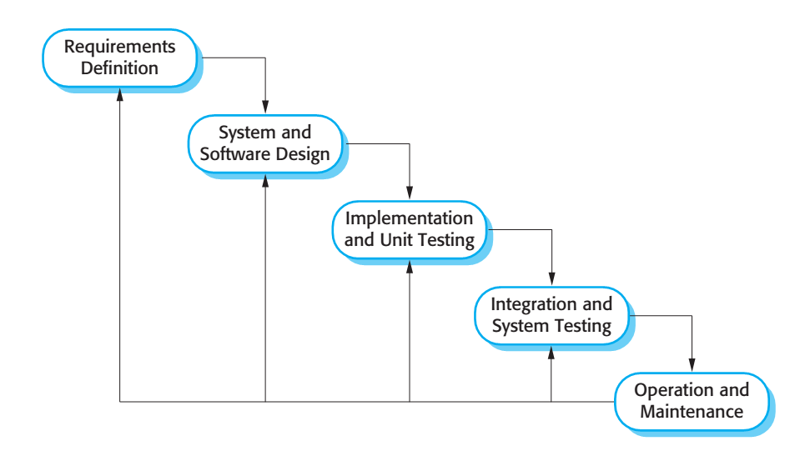

Figure 1: Waterfall model

1. Roles and responsibilities

|  |  |  |  |
| --- | --- | --- | --- |
| No | Full name | Role in Group | Responsibilities |
| 1 | Hồ Hoàn Kiếm | Supervisor / Project Manager | - Technical support and business analysis.  - Support basic code  - Review document and product. |
| 2 | Võ Huỳnh Đức Minh | Team leader, Developer, Tester | - Tracking process.  - Planning project, distribute tasks.  - Requirement analysis.  - GUI Design.  - Coding.  - Testing.  - Deploy product. |
| 3 | Nguyễn Công Bảo | Developer, Tester | - Requirement analysis.  - Database design.  - Documentation.  - Back-end Design  - Coding.  - Testing. |

1. Tool and Techniques

|  |  |
| --- | --- |
| Tool / Technique | Name / version |
| Frontend | HTML, CSS, JavaScript, Ajax, Bootstrap |
| Backend | C#,API |
| Web server | IIS Express |
| Development tool | Visual Studio 2019, Visual Studio Code |
| DBMS | SQL Server 2014 |
| Modeling tool | StarUML 5.0 |
| Document tool | Microsoft Word 2010 |

1. Software Requirement Specification
2. User Requirement Specification
3. Customer requirement  
   Customer is user who uses service of system. The customer can use some following functions:  
   - Create new account  
   - Login / Logout account  
   - View list of product  
   - View product detail  
   - Do shopping with shopping cart  
   - Add product to cart  
   - Remove product from cart  
   - Choose payment method  
   - Choose delivery method   
   - View personal information
4. Admin requirement  
   - Manage Product  
   - Manage User  
   - Set role
5. System Requirement Specification
6. External Interface Requirement

* The user interface uses Vietnamese language.
* Use consistent palette of colors between the text and the background.
* The user interface displays best on 1024x768-screen size.
* Web application: works with Firefox(v69.0 or above),Safari(v13 or above), Chromes (v80.0 or above), Internet Explorer (v11 or above) browse
* Use HTTP protocol 1.1 for communication between the web browser and the web server.

1. System Overview Use Case

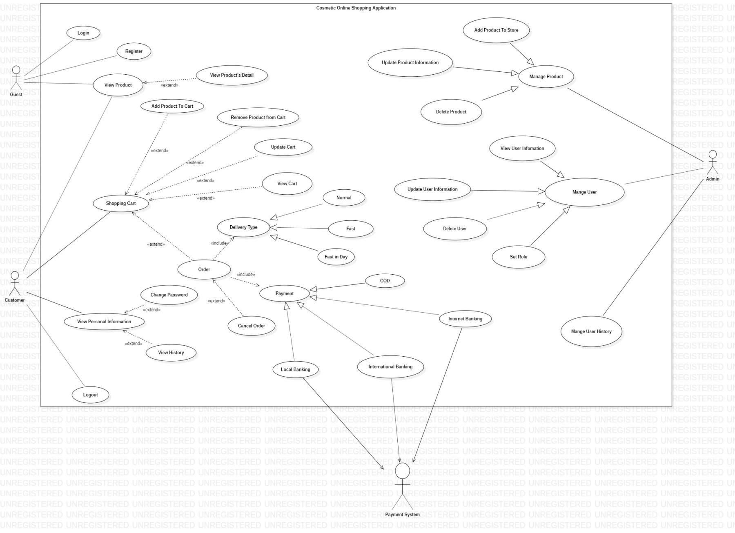

|  |  |  |  |
| --- | --- | --- | --- |
| ID and Name: | **UC-1 Order Product** | | |
| Created By: | Group 2 | Date Created: | 4/4/2020 |
| Primary Actor: | User | Secondary Actors: | System Management (SM) |
| Description: | A Customer accesses Shopping from the corporate intranet or from home, views the menu for a specific product if desired, add product to cart, and make an order | | |
| Trigger: | A Customer must have at least 1 product in cart | | |
| Preconditions: | PRE-1. Customer is accessed into Shopping. | | |
| Post conditions: | POST-1. Product order is stored in Shopping with a status of “Ordered”.  POST-2. Order detail will be updated into System Management. | | |
| Normal Flow: | * 1. **Order a Single Product**  1. Customer click “view cart” button from top-right of menu 2. Customer click “order” button   2.1 If customer hasn’t logged into system they must perform UC-3 or UC-7   * 1. Customer asks to view list of products.   2. App displays menu of available product items and the daily special.   3. Customer selects one or many products from menu.   4. Customer click “order” button.   5. Customer choose delivery type and payment (UC-10).   6. App displays ordered menu products, individual prices, and total price, including taxes.   7. App either confirms order (continue normal flow) or requests to modify order (return to step 2).   8. App sends Customer an email message confirming order details, price, and appointment information.   9. App stores order, sends order detail to System Management. | | |
| Exceptions: | **1.0.E2 No times left to cancel order**  1. System informs Customers that they can’t cancel the order process when product has been delivered but they still can refuse the product.  2a. If Customers use credit card the product and money will be returned to its owner;  2b. Else if Customer choose Ship COD the product will be returned to its owner  **1.1.E1 Insufficient inventory to fulfill multiple products order**  1. System informs Customer of the maximum number of identical products he can order, based on current available inventory.  2a. If Customer modifies number of products ordered, then Return to step 4 of normal flow.  2b. Else if Patron cancels the products ordering process, then System terminates use case. | | |
| Priority: | High | | |
| Frequency of Use: | Approximately 300 users, average of one usage per day. Peak usage load for this use case is between 9:00 A.M. and 10:00 A.M. local time. | | |
| Business Rules: |  | | |
| Other Information: | 1. Customer shall be able to cancel the product ordering process at any time prior to confirming it. 2. Customer shall be able to view all products he ordered within the previous six months and repeat one of those products as the new order. | | |
| Assumptions: | Assume that 15 percent of Customers will order the daily special | | |

|  |  |  |  |
| --- | --- | --- | --- |
| ID and Name: | **UC-2 Search Products** | | |
| Created By: | Group 2 | Date Created: | 4/4/2020 |
| Primary Actor: | User | Secondary Actors: | System Management (SM) |
| Description: | A Customer accesses E Shopping from the corporate intranet or from home, views the menu for a specific product if desired by its name or ability | | |
| Trigger: | A Customer must fill at least 1 character in the search bar | | |
| Preconditions: | PRE-1. Customer is accessed into E Shopping. | | |
| Post conditions: | List of all products contain the search values will be displayed with full name, price, sale price (if any) and picture | | |
| Normal Flow: | 1. Customer type anything on search bar and click “search” button. 2. App accessed SM to get all products contains the search values 3. App displays menu of available product items include full name, price, sale price, picture, rate to Customer. | | |
| Priority: | Medium | | |
| Frequency of Use: | Approximately 1500 users, average of one usage per day. Peak usage load for this use case is between 9:00 A.M. and 10:00 A.M. local time. | | |
| Business Rules: |  | | |

|  |  |  |  |
| --- | --- | --- | --- |
| ID and Name: | **UC-3 Login** | | |
| Created By: | Group 2 | Date Created: | 4/4/2020 |
| Primary Actor: | Customer | Secondary Actors: |  |
| Description: | A Customer accesses E Shopping from the corporate intranet or from home, login to system to be able to make order | | |
| Trigger: | A Customer is unauthorized user | | |
| Preconditions: | PRE-1. Customer is accessed into E Shopping. | | |
| Post conditions: | Customer has the ability to perform order product if login successfully | | |
| Normal Flow: | **1.0 Click “Login” button to perform use case**   1. Customer “login” button at the top right of the App. 2. Customer type his username and password and click “OK” button. 3. System check the request from customer to find their account from database    1. If login successfully their profile will be displayed at the top right of the App    2. Else if login fail the system will informs to customer | | |
| Alternative Flows: | **1.1 Perform Order function before Login**  1. Customer performs step 1-7 of Normal Flow from UC-1  2. System will show the login form if customer is unauthorized user  3. return to step 2 of Normal Flow | | |
| Priority: | High | | |
| Frequency of Use: | Approximately 1500 users, average of one usage per day. Peak usage load for this use case is between 9:00 A.M. and 10:00 A.M. local time. | | |
| Business Rules: |  | | |

|  |  |  |  |
| --- | --- | --- | --- |
| ID and Name: | **UC-4 Add product to cart** | | |
| Created By: | Group 2 | Date Created: | 4/4/2020 |
| Primary Actor: | Customer | Secondary Actors: | System Management |
| Description: | A Customer accesses E Shopping from the corporate intranet or from home, views the menu for a specific product if desired or search it on the search bar and add product to cart | | |
| Trigger: | A Customer must choose at least 1 product | | |
| Preconditions: | PRE-1. Customer is accessed into E Shopping. | | |
| Post conditions: | Product information is stored in Customer’s cart with name, picture, total price and quantity. | | |
| Normal Flow: | **1.0 Add product to cart from Main page**   1. Customer select a product from Main Page. 2. App accessed SM to get full information of product and display to customer. 3. Customer choose “Add to cart” button. 4. App ask customer to choose quantity of the product from 1 to its available   quantity (default is 1)   1. Customer choose quantity and click “Confirm”. 2. App store information of product to Customer’s cart | | |
| Alternative Flows: | **1.1 Perform Search function before add product to cart**  1. Customer performs all step of Normal Flow from UC-2  2. Customer select a product  3. return to step 2 of Normal Flow | | |
| Priority: | High | | |
| Frequency of Use: | Approximately 700 users, average of one usage per day. Peak usage load for this use case is between 9:00 A.M. and 10:00 A.M. local time. | | |
| Business Rules: |  | | |
| Other Information: | 1. Customer shall be able to remove the product or edit product quantity from cart at any time before ordering. 2. Customer shall be able to view all products he ordered within the previous six months and repeat one of those products as the new order. | | |

|  |  |  |  |
| --- | --- | --- | --- |
| ID and Name: | **UC-5 Remove Product** | | |
| Created By: | Group 2 | Date Created: | 4/4/2020 |
| Primary Actor: | Customer | Secondary Actors: | System Management (SM) |
| Description: | A Customer accesses E Shopping from the corporate intranet or from home, check his cart and if there are some products he doesn’t desire he can remove them from the cart | | |
| Trigger: | A Customer must have at least 1 product in cart | | |
| Preconditions: | PRE-1. Customer is accessed into E Shopping.  PRE-2. Customer is accessed into cart | | |
| Post conditions: | Product that customer removed won’t appear in the cart | | |
| Normal Flow: | 1. Customer click “cart” button from top-right of menu. 2. System displays menu of product price, quantity he just added. 3. Customer choose the arrow next to the product he want to remove. 4. Customer click “remove” button. 5. The product will disappear from Customer’s cart. | | |
| Priority: | Medium | | |
| Frequency of Use: | Approximately 300 users, average of one usage per day. Peak usage load for this use case is between 9:00 A.M. and 10:00 A.M. local time. | | |
| Business Rules: |  | | |
| Other Information: | 1. Customer shall be able to remove the product from cart at any time prior to confirming it. 2. Customer shall be able to view all products he ordered within the previous six months and repeat one of those products as the new order. | | |
| Assumptions: | Assume that 5 percent of Customers will remove product from cart | | |

|  |  |  |  |
| --- | --- | --- | --- |
| ID and Name: | **UC-6 Update Product Cart** | | |
| Created By: | Group 2 | Date Created: | 4/4/2020 |
| Primary Actor: | Customer | Secondary Actors: |  |
| Description: | A Customer accesses E Shopping from the corporate intranet or from home, views their cart and edit the product | | |
| Trigger: | A Customer must have at least 1 product in cart | | |
| Preconditions: | PRE-1. Customer is accessed into E Shopping.  PRE-2. Customer is accessed into cart | | |
| Post conditions: | Information of product in cart will be changed up to Customer | | |
| Normal Flow: | 1. Customer click “cart” button from top-right of menu. 2. App displays menu of product price, quantity he just added. 3. Customer choose the arrow next to the product he wants to update. 4. Customer click “+” or “-” button to edit quantity. 5. The quantity of product will change from Customer’s cart.. | | |
| Priority: | Medium | | |
| Frequency of Use: | Approximately 300 users, average of one usage per day. Peak usage load for this use case is between 9:00 A.M. and 10:00 A.M. local time. | | |
| Business Rules: |  | | |
| Other Information: | 1. Customer shall be able to cancel the product ordering process at any time prior to confirming it. 2. Customer shall be able to view all products he ordered within the previous six months and repeat one of those products as the new order. | | |
| Assumptions: | Assume that 15 percent of Customers will update the daily special | | |

|  |  |  |  |
| --- | --- | --- | --- |
| ID and Name: | **UC-7 Register** | | |
| Created By: | Group 2 | Date Created: | 4/4/2020 |
| Primary Actor: | Customer | Secondary Actors: |  |
| Description: | A Customer accesses E Shopping from the corporate intranet or from home, register to login and order product | | |
| Trigger: | Customer doesn’t login before | | |
| Preconditions: | PRE-1. Customer is accessed into E Shopping. | | |
| Post conditions: | New account will be created so customer and order and manage their order | | |
| Normal Flow: | **1.0 Register from Main page**   1. Customer click “register” button from top-right of menu. 2. App displays form of account include passport, address, phone, username (unique), password, email 3. Customer must type all fields that have been listed . 4. Customer click “ok” button to finish.    1. If creating successfully customers can use their account    2. Else customer must enter all fields correctly again... | | |
| Alternative Flows: | **1.1 Register when ordering**  1. Customer performs UC-1  2. System will display register form for Customer  3. Perform step 3 to 5 of Normal Flow | | |
| Priority: | High | | |
| Frequency of Use: | Approximately 500 users, average of one usage per day. Peak usage load for this use case is between 9:00 A.M. and 10:00 A.M. local time. | | |
| Business Rules: |  | | |
| Assumptions: | Assume that 5 percent of Customers will create new account daily | | |

|  |  |  |  |
| --- | --- | --- | --- |
| ID and Name: | **UC-8 Cancel order** | | |
| Created By: | Group 2 | Date Created: | 4/4/2020 |
| Primary Actor: | Customer | Secondary Actors: | System Management (SM) |
| Description: | Customers access E Shopping from the corporate intranet or from home, cancel their order if the products haven’t delivered to them yet. | | |
| Trigger: | Customer must have order that hasn’t delivered to them. | | |
| Preconditions: | PRE-1. Customer is accessed into E Shopping.  PRE-2. Customer login into E Shopping.  PRE-3. Customer access to their order. | | |
| Post conditions: | The order will be canceled, product will be returned to stock and money will be returned to customer | | |
| Normal Flow: | 1. Customers click “view order” button from top-right of menu.    1. If customers haven’t logged in before they must perform UC-3 or UC-7.    2. Else all orders of them are displayed.    3. Customers choose an order and click “cancel order” button (only orders that haven’t delivered yet having the button)    4. Customers confirm their process   5.2 System connect to SM to update products, delete order  6.2 Money will be sent back to Customer’s cards 1 or 2 days later. | | |
| Priority: | Medium | | |
| Frequency of Use: | Approximately 100 users, average of one usage per day. Peak usage load for this use case is between 9:00 A.M. and 10:00 A.M. local time. | | |
| Business Rules: |  | | |
| Assumptions: | Assume that 1 percent of Customers will cancel their order | | |

|  |  |  |  |
| --- | --- | --- | --- |
| ID and Name: | **UC-9 Log out** | | |
| Created By: | Group 2 | Date Created: | 4/4/2020 |
| Primary Actor: | Customer | Secondary Actors: |  |
| Description: | Customers accesses E Shopping from the corporate intranet or from home, login and logout to protect their account | | |
| Trigger: | Customer must have logged into system. | | |
| Preconditions: | PRE-1. Customer is accessed into E Shopping.  PRE-2. Customer login into E Shopping. | | |
| Post conditions: | Customer’s account will be removed from their browser | | |
| Normal Flow: | 1. Customers click into log out button from their profile from top-left of menu.   * 1. If customers haven’t logged in before they must perform UC-3 or UC-7.   2. Else their account will be removed from their browser | | |
| Priority: | Medium | | |
| Frequency of Use: | Approximately 100 users, average of one usage per day. Peak usage load for this use case is between 9:00 A.M. and 10:00 A.M. local time. | | |
| Business Rules: |  | | |
| Assumptions: | Assume that 0.5 percent of Customers will logout | | |

|  |  |  |  |
| --- | --- | --- | --- |
| ID and Name: | **UC-10 Choose shipping type** | | |
| Created By: | Group 2 | Date Created: | 4/4/2020 |
| Primary Actor: | Customer | Secondary Actors: |  |
| Description: | Customers accesses E Shopping from the corporate intranet or from home, order product and choose shipping type to deliver order to the address. | | |
| Trigger: | Customer must perform order use case (UC-1) | | |
| Preconditions: | PRE-1. Customer is accessed into Shopping.  PRE-2. Customer login into Shopping.  PRE-3. Customer order products | | |
| Post conditions: | Base on customer’s choice, system will add shipping fee to the order | | |
| Normal Flow: | * 1. Customers perform UC-1.   2. System display 3 choice: normal, fast, fast today.   3. Customer chose 1 of that type.   4. System add shipping fee to customer’ order.   5. Customer confirms the order. | | |
| Priority: | High | | |
| Business Rules: |  | | |

|  |  |  |  |
| --- | --- | --- | --- |
| ID and Name: | **UC-11 Choose payment** | | |
| Created By: | Group 2 | Date Created: | 4/4/2020 |
| Primary Actor: | Customer | Secondary Actors: |  |
| Description: | Customers accesses Shopping from the corporate intranet or from home, order product and choose payment to pay the order. | | |
| Trigger: | Customer must perform order use case (UC-1) | | |
| Preconditions: | PRE-1. Customer is accessed into Shopping.  PRE-2. Customer login into Shopping.  PRE-3. Customer order products | | |
| Post conditions: | Base on customer’s choice, system will receive customer’s information card or ship COD and make payment | | |
| Normal Flow: | * 1. Customers perform UC-1.   2. System display 2 choice: credit card, ship COD.   3. Customer chose 1 of that type.   4. If customer chose credit card system display form content type, name, owner’s name, card security value.   5. Customers fill all fields and click “OK”   5. System confirms | | |
| Priority: | High | | |
| Business Rules: |  | | |

|  |  |  |  |
| --- | --- | --- | --- |
| ID and Name: | **UC-12 Add Product To Store** | | |
| Created By: | Group 2 | Date Created: | 4/4/2020 |
| Primary Actor: | Admin | Secondary Actors: |  |
| Description: | Admin login to the website and go to admin page on navigation bar component. The screen task of admin will display with 2 card: User and Product. Admin will add Product at Product tab | | |
| Trigger: | Admin must perform order use case (UC-3) | | |
| Preconditions: | PRE-1. Admin is accessed into Shopping.  PRE-2. Admin login into Shopping.  PRE-3. Admin go to admin page | | |
| Post conditions: |  | | |
| Normal Flow: | * 1. Admin perform UC-3.   2. Click on admin item on navigation bar   3. Click on Product tab on left bar   4. Input product information on task screen.   5. Click add and wait message from server. | | |
| Priority: | High | | |
| Business Rules: |  | | |

|  |  |  |  |
| --- | --- | --- | --- |
| ID and Name: | **UC-13 Update Product Information** | | |
| Created By: | Group 2 | Date Created: | 4/4/2020 |
| Primary Actor: | Admin | Secondary Actors: |  |
| Description: | Admin login to the website and go to admin page on navigation bar component. The screen task of admin will display with 2 card: User and Product. Admin will update Product at Product tab | | |
| Trigger: | Admin must perform order use case (UC-3) | | |
| Preconditions: | PRE-1. Admin is accessed into Shopping.  PRE-2. Admin login into Shopping.  PRE-3. Admin go to admin page | | |
| Post conditions: |  | | |
| Normal Flow: | * 1. Admin perform UC-3.   2. Click on admin item on navigation bar   3. Click on Product tab on left bar   4. Modify product information on task screen.   5. Click update product and wait message from server. | | |
| Priority: | High | | |
| Business Rules: |  | | |

|  |  |  |  |
| --- | --- | --- | --- |
| ID and Name: | **UC-14 Delete Product To Store** | | |
| Created By: | Group 2 | Date Created: | 4/4/2020 |
| Primary Actor: | Admin | Secondary Actors: |  |
| Description: | Admin login to the website and go to admin page on navigation bar component. The screen task of admin will display with 2 card: User and Product. Admin will delete Product at Product tab | | |
| Trigger: | Admin must perform order use case (UC-3) | | |
| Preconditions: | PRE-1. Admin is accessed into Shopping.  PRE-2. Admin login into Shopping.  PRE-3. Admin go to admin page | | |
| Post conditions: |  | | |
| Normal Flow: | * 1. Admin perform UC-3.   2. Click on admin item on navigation bar   3. Click on Product tab on left bar   4. Delete an existence product.   5. Wait message from server. | | |
| Priority: | High | | |
| Business Rules: |  | | |

|  |  |  |  |
| --- | --- | --- | --- |
| ID and Name: | **UC-15 View User Information** | | |
| Created By: | Group 2 | Date Created: | 4/4/2020 |
| Primary Actor: | Admin | Secondary Actors: |  |
| Description: | Admin login to the website and go to admin page on navigation bar component. The screen task of admin will display with 2 card: User and Product. Admin will add User at User tab | | |
| Trigger: | Admin must perform order use case (UC-3) | | |
| Preconditions: | PRE-1. Admin is accessed into Shopping.  PRE-2. Admin login into Shopping.  PRE-3. Admin go to admin page | | |
| Post conditions: |  | | |
| Normal Flow: | * 1. Admin perform UC-3.   2. Click on admin item on navigation bar   3. Click on User tab on left bar   4. The main screen will display information of user | | |
| Priority: | High | | |
| Business Rules: |  | | |

|  |  |  |  |
| --- | --- | --- | --- |
| ID and Name: | **UC-16 Update User Information** | | |
| Created By: | Group 2 | Date Created: | 4/4/2020 |
| Primary Actor: | Admin | Secondary Actors: |  |
| Description: | Admin login to the website and go to admin page on navigation bar component. The screen task of admin will display with 2 card: User and Product. Admin will update User at User tab | | |
| Trigger: | Admin must perform order use case (UC-3) | | |
| Preconditions: | PRE-1. Admin is accessed into Shopping.  PRE-2. Admin login into Shopping.  PRE-3. Admin go to admin page | | |
| Post conditions: |  | | |
| Normal Flow: | * 1. Admin perform UC-3.   2. Click on admin item on navigation bar   3. Click on User tab on left bar   4. Select user for update   5. Modify user information on task screen.   6. Click update and wait for message from server | | |
| Priority: | High | | |
| Business Rules: |  | | |

|  |  |  |  |
| --- | --- | --- | --- |
| ID and Name: | **UC-17 Delete User** | | |
| Created By: | Group 2 | Date Created: | 4/4/2020 |
| Primary Actor: | Admin | Secondary Actors: |  |
| Description: | Admin login to the website and go to admin page on navigation bar component. The screen task of admin will display with 2 card: User and Product. Admin will delete User at User tab | | |
| Trigger: | Admin must perform order use case (UC-3) | | |
| Preconditions: | PRE-1. Admin is accessed into Shopping.  PRE-2. Admin login into Shopping.  PRE-3. Admin go to admin page | | |
| Post conditions: |  | | |
| Normal Flow: | * 1. Admin perform UC-3.   2. Click on admin item on navigation bar   3. Click on User tab on left bar   4. Select user for delete.   5. Click delete and wait for message from server | | |
| Priority: | High | | |
| Business Rules: |  | | |

|  |  |  |  |
| --- | --- | --- | --- |
| ID and Name: | **UC-18 Set role** | | |
| Created By: | Group 2 | Date Created: | 4/4/2020 |
| Primary Actor: | Admin | Secondary Actors: |  |
| Description: | Admin login to the website and go to admin page on navigation bar component. The screen task of admin will display with 2 card: User and Product. Admin will set role User at User tab | | |
| Trigger: | Admin must perform order use case (UC-3) | | |
| Preconditions: | PRE-1. Admin is accessed into Shopping.  PRE-2. Admin login into Shopping.  PRE-3. Admin go to admin page | | |
| Post conditions: |  | | |
| Normal Flow: | * 1. Admin perform UC-3.   2. Click on admin item on navigation bar   3. Click on User tab on left bar   4. Select user for set role and input role id.   5. Click update and wait for message from server. | | |
| Priority: | High | | |
| Business Rules: |  | | |

1. Software System Attribute
2. Usability

All the texts, labels and alerts will be written in Vietnamese.

The system usability is easy to use that will need less than 3 days of training for company admin to use the system.

1. Reliability

Scheduler task run at 00:00 every day with 100% execution rate.

Web service API response success rate is less than 2 failed requests per 1000 requests.

1. Security

All input data are validated before saving to database.

1. Maintainability

The system is separated into modules.

1. Portability

Admin and user can use application on every OS supported web browser.

1. Performance

Requests from web application are responded in less than 10 seconds at 8 Mbps bandwidth speed.

1. ER Diagram

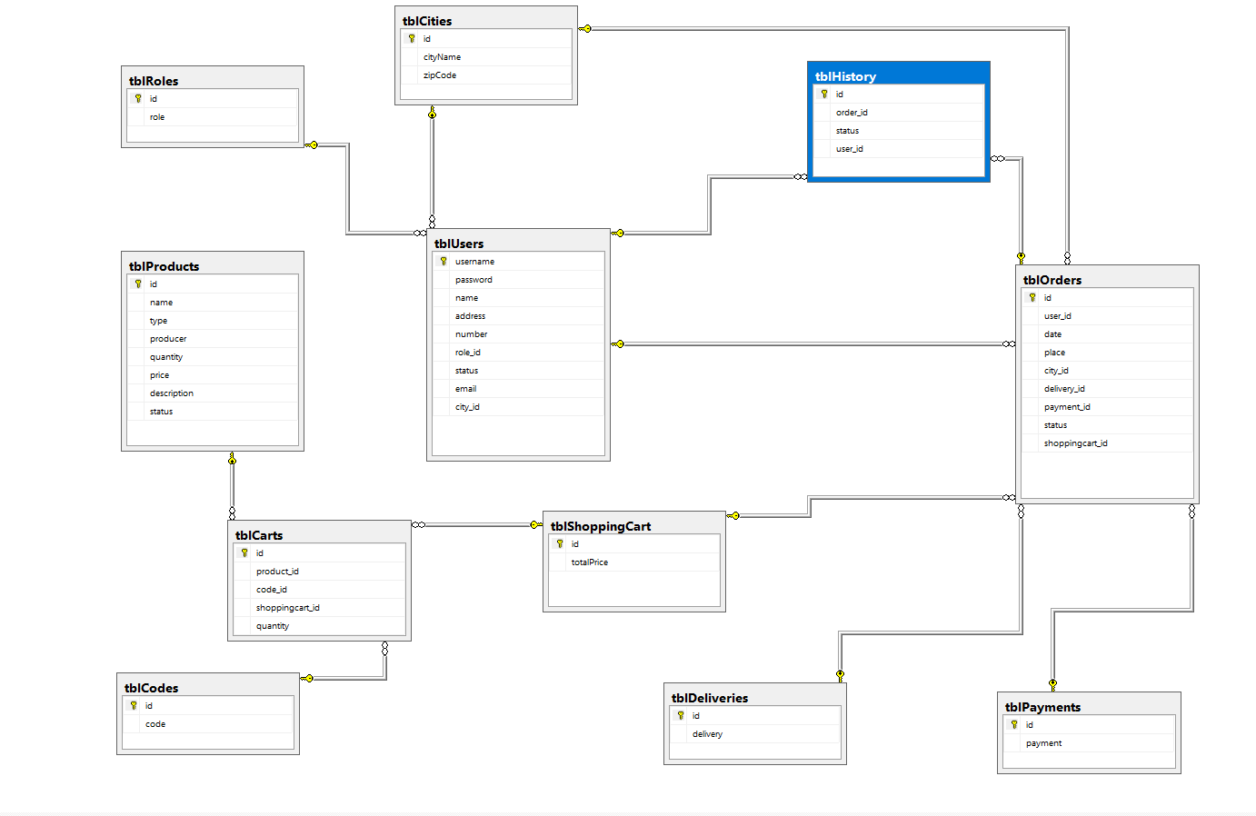

1. Software Design Description
2. Design Overview

This document describes the technical and user interface design of MIC system. It includes the architectural design, the detailed design of common functions and business functions and the design of database model.

The architectural design describes the overall architecture of the system and the architecture of each main component and subsystem.

The detailed design describes static and dynamic structure for each component and functions. It includes class diagrams, class explanations and sequence diagrams for each use cases.

The database design describes the relationships between entities and details of each entity.

Document overview:

* 1. Section 2: gives an overall description of the system architecture design.
  2. Section 3: gives component diagrams that describe the connection and integration of the system.
  3. Section 4: gives the detail design description, which includes class diagram, class explanation, and sequence diagram to details the application functions.
  4. Section 5: describe a fully attributed Entity Relationship Diagram.

1. System Architecture Design

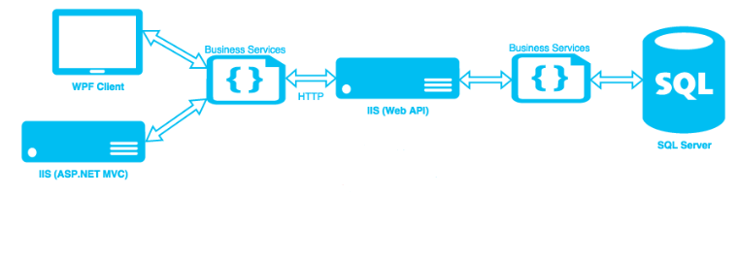

**Web Application architecture description:** In Web Application, the system is developed under ASP.Net MVC architecture style. We choose this architecture for Web application because of following advantages:

* Web app contains a Web service API with MVC architecture, we can separate business code with Controller and View, so we can use the business code in web service without repeat the code.
* In scope of 2-member team, MVC architecture make it easier to split the big project into 2 separate task: front-end and back-end, make it easier to assign each module for members in our team.

This project follows MVC architecture with following components:

* **ASP.Net (Controller)** is the parts of the application that acts like event handler to handles user interaction. Typically, controller read data from a request and calls appropriate Business’s method then selects view to return to user.
* **HTML (View)** is the parts of the application that handles the display of the data. The selection of View is under control of Controller.
* **Business** is the parts of the application that do business processing to solve domain problems.
* **Model** is the parts of the application that acts like a data transfer object between the system and database.
* **Web Service** is the parts of the application that acts like event handler for web and mobile communication via API RESTful method.

1. Component Diagram

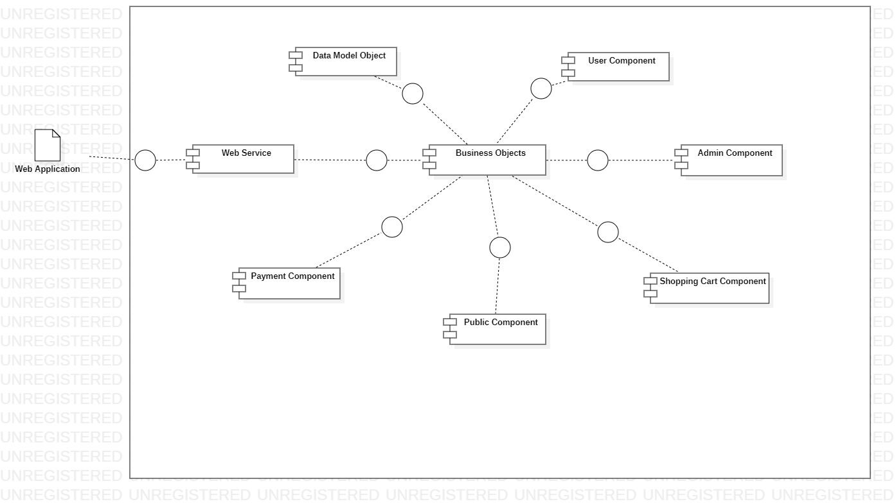

|  |  |
| --- | --- |
| Component Dictionary: Describes components | |
| Web Application | Web application package: View, Controller |
| Payment Component | Component to handle payment process |
| Web Service | operations o handle interaction between the system and database.Provide API for web applications to interact with the system. |
| User Component | Component to handle user activities in the system |
| Public Component | Component to handle guest activities in the system |
| Admin Component | Component to handle admin activities in the system |
| Shopping Cart Component | Component to handle shopping in the system |
| Business Objects | Common objects to handle domain business operations for each components |
| Data Model Objects | Component to handle interaction between the system and database |

1. Detailed Description

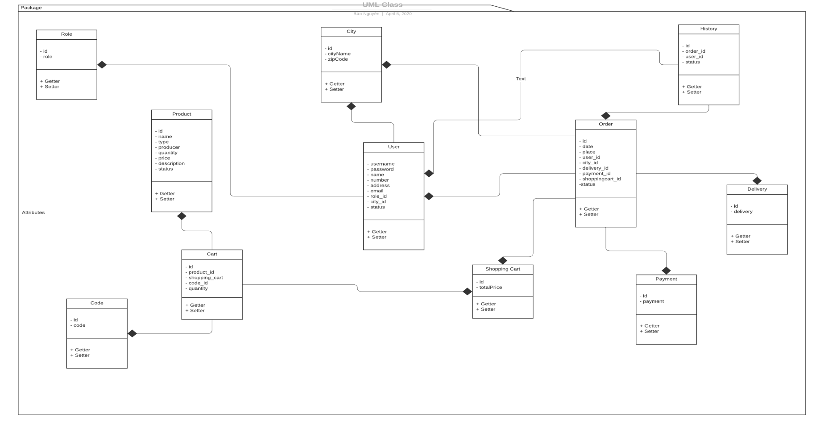

|  |  |  |
| --- | --- | --- |
| Class dictionary: describe Class | | |
| Class Name | **Mapping column with Conceptual diagram** | **Description** |
| PaymentEntity | Payment | Contain the payment type information. |
| CartEntity | Cart | Contain the cart information. |
| ShoppingCartEntity | Shopping Cart | Contain the shopping card instance information |
| UserEntity | User | Contain the user information. |
| RoleEntity | Role | Contain the role information. |
| HistoryEntity | History | Contain the history information. |
| DeliveryEntity | Delivery | Contain the delivery type information. |
| CodeEntity | Code | Contain the code information. |
| OrderEntity | Order | Contain the order information. |
| ProductEntity | Product | Contain the product information. |
| CityEntity | City | Contain the city information. |

**Class Diagram Explanation**

1. PaymentEntity

|  |  |  |  |
| --- | --- | --- | --- |
| Attribute | Type | Visibility | Description |
| id | string | public | Unique identifier of an payment |
| payment | string | public | The type of payment |

1. CartEntity

|  |  |  |  |
| --- | --- | --- | --- |
| Attribute | Type | Visibility | Description |
| id | string | public | Unique identifier of an cart |
| product_id | string | public | The product transaction ID |
| code_id | string | public | The code transaction ID |
| shoppingcart_id | string | public | The shopping cart transaction ID |
| quantity | int | public | Number of product |

1. ShoppingCartEntity

|  |  |  |  |
| --- | --- | --- | --- |
| Attribute | Type | Visibility | Description |
| Id | string | public | Unique identifier of an shopping cart |
| totalPrice | int | public | The total price of shopping cart |

1. UserEntity

|  |  |  |  |
| --- | --- | --- | --- |
| Attribute | Type | Visibility | Description |
| username | string | public | Unique identifier of an user |
| password | string | public | Value to authentication user |
| name | string | public | The name user information |
| address | string | public | The address information |
| email | string | public | The email information |
| number | string | public | The number information |
| role_id | string | public | The role transaction ID |
| city_id | string | public | The city transaction ID |
| status | bool | public | The available of status |

1. RoleEntity

|  |  |  |  |
| --- | --- | --- | --- |
| Attribute | Type | Visibility | Description |
| id | string | public | Unique identifier of a role |
| role | string | public | The role information |

1. HistoryEntity

|  |  |  |  |
| --- | --- | --- | --- |
| Attribute | Type | Visibility | Description |
| id | string | public | Unique identifier of a history |
| order_id | string | public | The order transaction ID |
| user_id | string | public | The user transaction ID |
| status | string | public | The available of status |

1. DeliveryEntity

|  |  |  |  |
| --- | --- | --- | --- |
| Attribute | Type | Visibility | Description |
| id | string | public | Unique identifier of an delivery |
| delivery | string | public | The type of delivery |

1. CodeEntity

|  |  |  |  |
| --- | --- | --- | --- |
| Attribute | Type | Visibility | Description |
| Id | string | public | Unique identifier of an code |
| code | string | public | The code information |

1. OrderEntity

|  |  |  |  |
| --- | --- | --- | --- |
| Attribute | Type | Visibility | Description |
| id | string | public | Unique identifier of an order |
| user_id | string | public | The user transaction ID |
| shoppingcart_id | string | public | The shopping cart transaction ID |
| date | DateTime | public | The date information |
| place | string | public | The location of order |
| city_id | string | public | The city transaction ID |
| delivery_id | string | public | The delivery transaction ID |
| payment_id | string | public | The payment transaction ID |
| status | bool | public | The available of status |

1. ProductEntity

|  |  |  |  |
| --- | --- | --- | --- |
| Attribute | Type | Visibility | Description |
| id | string | public | Unique identifier of a product |
| name | string | public | The name of product |
| type | string | public | The type information |
| producer | string | public | The producer information |
| quantity | int | public | The number of product |
| price | int | public | The price of product |
| description | string | public | The PayPal transaction ID |
| status | bool | public | The contract code. |

1. CityEntity

|  |  |  |  |
| --- | --- | --- | --- |
| Attribute | Type | Visibility | Description |
| id | string | public | Unique identifier of an payment |
| cityName | string | public | The day process the payment |
| zipCode | string | public | The payment method |

1. Sequence Diagram
2. Login
3. Logout



1. Add to Cart

